Profile in perseverance: Paterson immigrant wins student essay contest
March 3, 2015, 4:57 PM Last updated: Tuesday, March 3, 2015, 5:02 PM
By ED RUMLEY
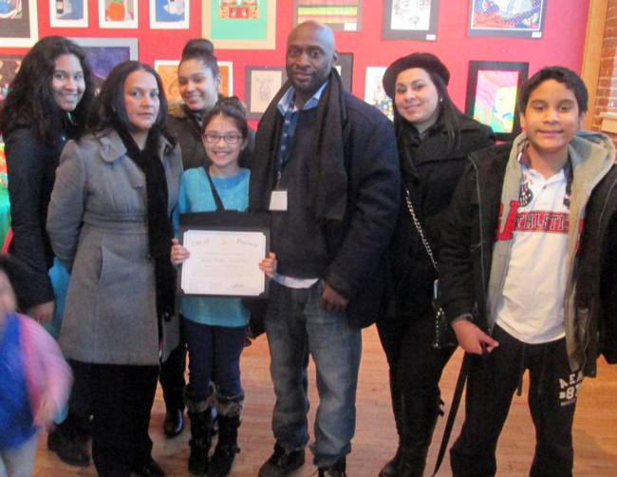

Ed Rumley/Paterson Press
Art award recipient Melanie Walker with family members and her art instructor Christopher Fabor Muhammad (to her right) at the Paterson Museum.
PATERSON — Two years ago, Jose Zelaya didn’t know English when he emigrated from Nicaragua as an eighth grader.
But the 15-year old sophomore at East Side High School learns fast, so fast, in fact, that he recently won second place in a Black History Month essay contest sponsored by the city and various Paterson-based nonprofit groups.
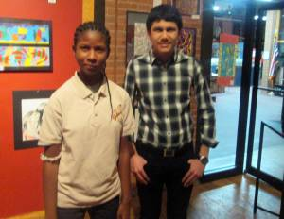

Ed Rumley/Paterson Press
Essay award winners Oliva Gauntlett and Jose Zelaya, at the Paterson Museum.
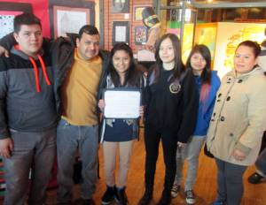

Ed Rumley/Paterson Press
Art award recipient Sandy Camargo with her family at the Paterson Museum.
“It was a challenge,” Zelaya said about coming to a new country where he did not speak the language. “I learned at school. I did vocabulary drills. My brother helped me.”
Fittingly, the topic of Zelaya’s essay focused on perseverance. “I wrote that success should be measured by the obstacles you overcome,” he said. “I was inspired by Booker T. Washington.”
Zelaya’s older brother, Raul, a college student, attended last Friday’s awards ceremony with him at the Paterson Museum. The siblings live with their father. Their mother remains in Nicaragua.
“We haven’t seen our mom for a year and a half,” the teenager said. “My father works hard as a supervisor at a laundry business. We hope to make enough money for her to be able to come here.”
The contest was organized by Inner Faith Performing Arts Center and co-sponsored by the New Jersey Grassroots Arts Commission, Women of Empowerment, and Heart of Hannah.
Another Eastside student, Olivia Gauntlett, was awarded first place in the high school essay division.
“I wrote about Black History and the success of how some iconic black people have overcome struggles” the 16-year junior said. “I used my overall knowledge and what I learned in history class. I was born in Jamaica and moved to the United States when I was 9 years old.”
Olivia attend the ceremony with her father, Oliver Gauntlett, and her mother, Millicent Gauntlett.
School 5 sixth grader Melanie Walker won second place prize in the middle school art division.
“I was searching about Black History month and saw a picture of an African American lady,” Melanie said. “It was so inspiring I decided to draw a similar one and have the names of famous black people in the background. My favorite is Maya Angelou. She was a writer, a dancer, and a poet. I like black history from the 1950’s and 1960’s. I like Martin Luther King, Rosa Parks, and Muhammad Ali. I did the outline at the school and finished it at the library on Union Avenue.”
Melanie attended the awards event with her mother, Lissette Milano, and art teacher, Christopher Fabor Muhammad.
Muhammad said Melanie not only excels in art but mentors other students as well.
“Melanie is working on a large project at school,” Muhammad said. “It is a mural which adorns a large portion of a wall in our classroom. It is her project. She helps other students learn to draw, trace, and paint with acrylics. Melanie loves art. She is very enthusiastic and dedicated.”
“Mr. Muhammad pushes us to the limit,” Melanie said. “He won’t let us stop at a certain amount. He lets us go on and on.”
Melanie said she and her mother are a team concerning the arts. “When she was three years old she was already drawing sunflowers,” Melanie’s mother said.
Another winner was Sandy Camargo an eighth grader from School 8, whose entry was an image she called “Triforce” from the video game Legend of Zelda. Her school art instructor, Anna Suralik, attended the ceremony.
“I started drawing bigger things recently, rather than just stick figures of doll houses,” Sandy said. “My drawing took me an hour and a half to make. My parents buy me supplies like paint and canvasses. They like to see me draw.
This week Ms. Suralik came to one of my classes and told me I had won. I was surprised and happy.”
“Melanie’s work was modern art,” Suralik said. “She worked with oil pastels for the value of color from lightest to darkest.
Receiving first place for art in the kindergarten through 3rd grade division was Lucy Cano, a third grader from School 8. The first place middle school art honor recipient was sixth grader Semaj Hill, from School 13.
The awards were distributed by Rashona Elder, director of the arts organization, and 4th Ward Councilwoman Ruby Cotton.
“I’m glad to see such vibrant and talented young people display their talent,” Elder said.
“It is so thrilling to see your children in art,” Cotton told parents. “It reaches their minds to higher things. It brings out the best in them.”

